**STOP PRESS!**

**If you read for just 20 minutes a day you will have read 1,800,000**

**words per year!**

**Spring (1) 2022 - issue 3**

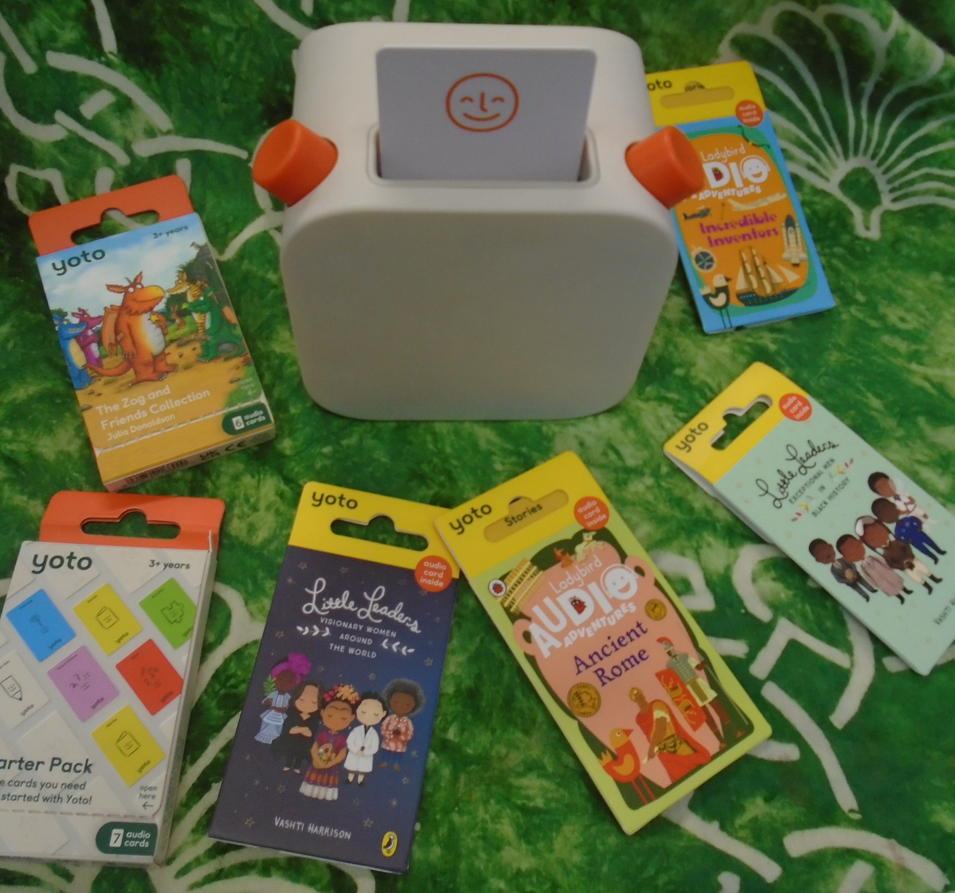

**Welcome to this half term’s Reading Corner!**

**We have added a Yoto and a range of audiobooks to our library and will be running a Yoto ‘audiobook club’ on a Tuesday playtime run by the children.**

Reading for pleasure has been widely researched and some of the benefits are listed below:

• Reading for pleasure has many non-literacy benefits and can increase empathy, improve relationships with others, reduce the symptoms of depression and improve wellbeing throughout life (The Reading Agency 2015).

• Reading for pleasure has social benefits as well and can make people feel more connected to the wider community. Reading increases a person’s understanding of their own identity, improves empathy and gives them an insight into the world view of others (The Reading Agency 2015).

• Students with more positive attitudes towards reading are more likely to read at or above the expected level for their age (Clark 2014).

• There is a strong association between the amount of reading for pleasure students say they do and their reading achievement (Twist 2007).

• Students who read for pleasure make significantly more progress in vocabulary, spelling and maths than children who read very little (Sullivan and Brown 2013).

We have added The Book Trust’s greatest books guide and recommended reads across all the year groups to our English Curriculum page on the website.

**Congratulations to Evelyn who won the Christmas ‘Reading in Strange Places’ Challenge! Thank you to everyone who sent in their weird and wonderful photos of strange places to read. They were all very imaginative! If your child has been inspired please do keep sending in photos for our display. You can view the photographs at: https://docs.google.com/presentation/d/1CsXv64WeyAN815PqUDZBnBf8YIIPNr5g/edit?usp=sharing&ouid=111451486513221541772&rtpof=true&sd=true**

This term we will be starting Book Buddies where once each half term the children will bring in a favourite book from home to share in class.

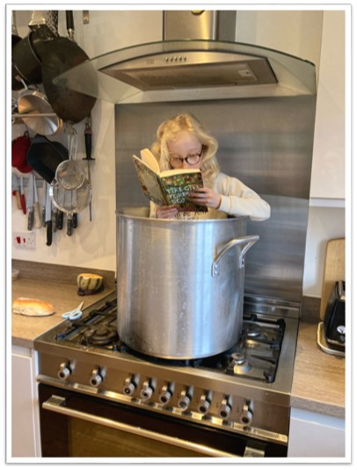

We also have access to a free online course for parents:

Raising a Reader: Top Tips for Parents to Foster a Love of Reading

This is a short course lasting 45 minutes and there are two dates to choose from: Wednesday 30th March 2022 7pm – 7.45pm

Thursday 23rd June 2022 7pm – 7.45pm

To book on the course, please use the link below: <https://www.dandelionlearning.co.uk/raising-a-reader-top-tips-for-parents-to-foster-a-love-of-reading-free-training/>

Four mornings a week the children in Key Stage One buddy up with a reading buddy from Key Stage Two to read their reading book and practise their handwriting.

